
CARROLL COUNTY ARTS COUNCIL
91 WEST MAIN STREET
WESTMINSTER, MARYLAND 21157
www.carrollartscenter.com
T: (410) 848 – 7272

Grant Representative: STEPHEN STROSNIDER
stephen@carrollcountyartscouncil.org
Office EX. 1090

FY26 COMMUNITY ARTS DEVELOPMENT (CAD) GRANT
GENERAL OPERATING BUDGET FINANCIAL REPORT
For nonprofit Arts Organizations ONLY
- Applicants must use this form to provide the required financial details. Applicants are given the opportunity to submit supplementary material if desired and/or complete a financial narrative within the SlideRoom application.
- This document is locked except for the areas that allow for applicant responses ( [ )
- Please format values as $2.87 or $3,400.00 where the cents are accounted for.
- Please leave any non-applicable areas blank – Do not write in zeros.
- If the organization needs additional rows or categories to adequately reflect the budgetary needs, please request a custom financial report by contacting the Grant Representative.
- For additional information, please reference the Glossary of Terms at the end of the FY26 CAD Grant Overview, Guidelines, and Resources document located here and on the website.
*ORGANIZATION:
 | BUDGETED  Most Recent Completed Year  Calendar Year 2024 or FY25 | ACTUALS  Most Recent Completed Year  Calendar Year 2024 | FY25 | BUDGETED  Calendar Year 2025 | FY26
INCOME
Contributed Income
*CCAC CAD Grant
Government Grants
Foundation Grants
Business Donations
In-Kind Donations ^{i.}
Individual Donations
Fundraisers
Other ^{ii.}
Earned Income
Tuition/Registration
Admissions/Ticket Sales
Contracted Services
Advertisement Sales
Goods/Services Sold
Investment/Interest
Other ^{iii.}
TOTAL INCOME*

 | BUDGETED  Most Recent Completed Year  Calendar Year 2024 | FY25 | ACTUALS  Most Recent Completed Year  Calendar Year 2024 | FY25 | BUDGETED  Calendar Year 2025 | FY26
EXPENSES
Operational
Fundraising
Organization Salaries & Fees
Professional Development
Administrative Supplies
Facility/Rental
Utilities
Accessibility
Equipment Purchase
Liability Insurance
Website Hosting/Service
Print Marketing
Digital Marketing
Misc. Marketing
Bank Charges/Processing
Allocation to Cash Reserves
Other ^{iv.}
Arts Programming
Awards/Contributions
Facility/Rental
Equipment Rental
Artistic Personnel Fees
Educational Personnel Fees
Technical Personnel Fees
Cost of Goods for Sale
Program Supplies
Other ^{v.}
TOTAL EXPENSES*
NET GAIN / (LOSS)*
If the following categories were given value, please provide specific details to help clarify:
Contributed Income | In-Kind Donation ^{i.}
Contributed Income | Other ^{ii.}
Earned Income | Other ^{iii.}
Operational Expenses | Other ^{iv.}
Arts Program  Expenses | Other ^{v.}
- Once completed, this document should be saved and uploaded to your secure, online SlideRoom application when prompted.

- REMINDER: THIS IS NOT THE FULL APPLICATION BUT A REQUIRED FORM TO BE COMPLETED AS A PART OF THE ONLINE APPLICATION.

TROUBLESHOOTING
1. A financial value table row is larger than the rest. Remove/Delete any unnecessary paragraphs created by pressing “Enter” after typing an amount.
2. There is not enough room in the detailed descriptions. Because all open spaces are freely editable, the table textbox will automatically expand to show text.
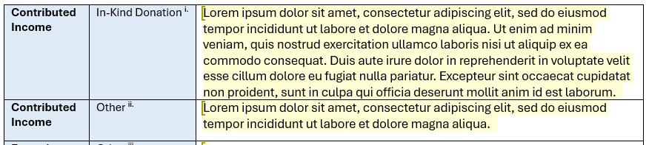

3. When I copy and paste in figures or text, they appear in different formats. By default, Word will paste information in its original format. To change this, you can select “Merge Formatting,” in Paste Options or you can highlight the pasted text and change the Font to Aptos, Font Style to Regular, and Font Size to 11pt.
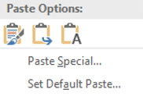
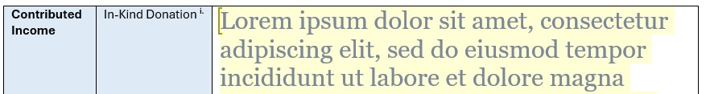

Please do not hesitate to contact the Grant Representative
with any questions or concerns regarding the application process!

